Tenant Disclosure Form Processing via DocuSign – Why the Date Matters
Objective
To provide a clear and concise procedure for sending tenant disclosure forms via DocuSign, ensuring compliance and accuracy in documentation.
Key Steps

1. Identify the Need for Tenant Disclosure Form 0:00
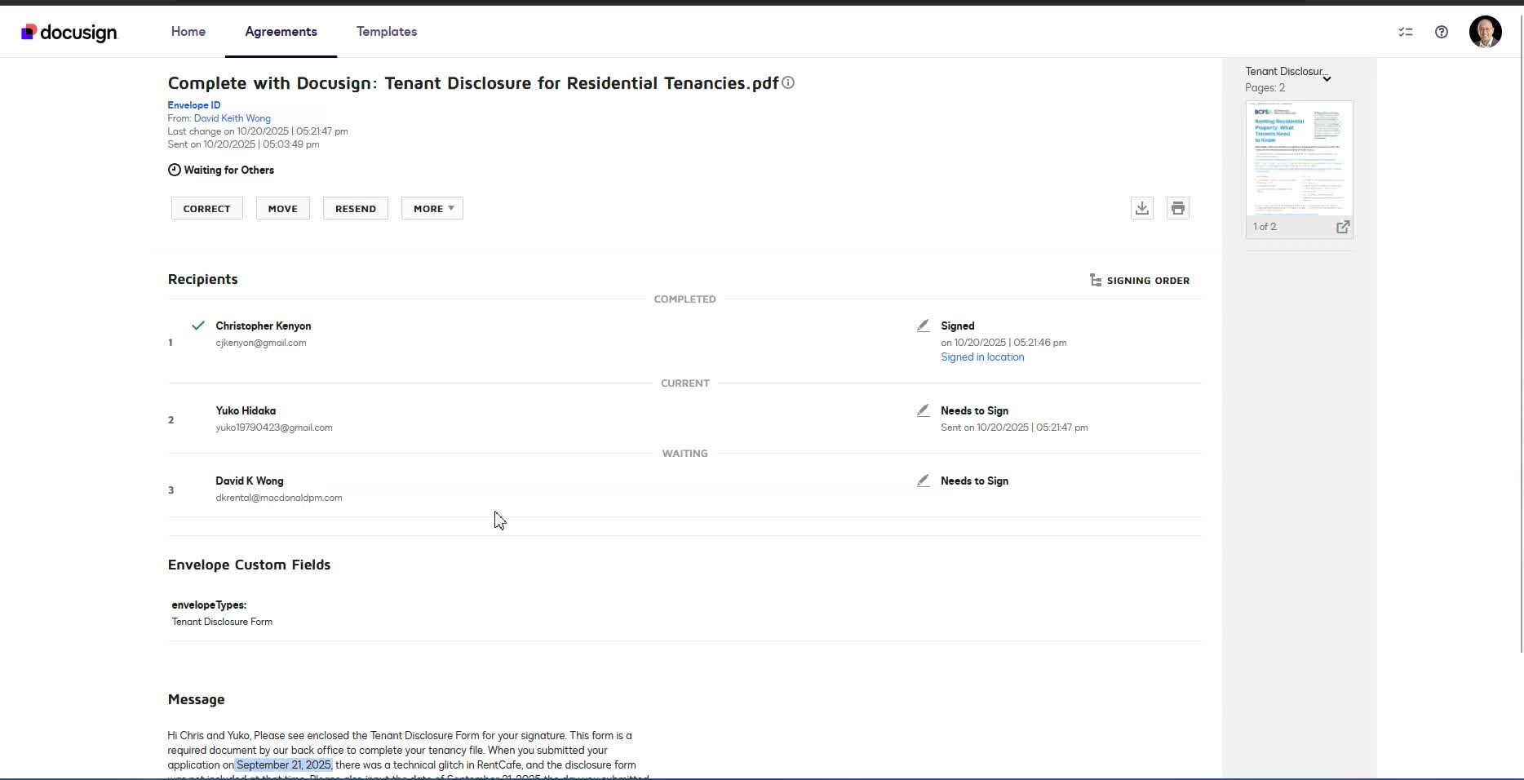
- Recognize that a tenant disclosure form must be sent via DocuSign due to a bypass in the Rent Café application process.
- Ensure compliance with mandatory requirements.

2. Confirm Application Processing Date 1:20
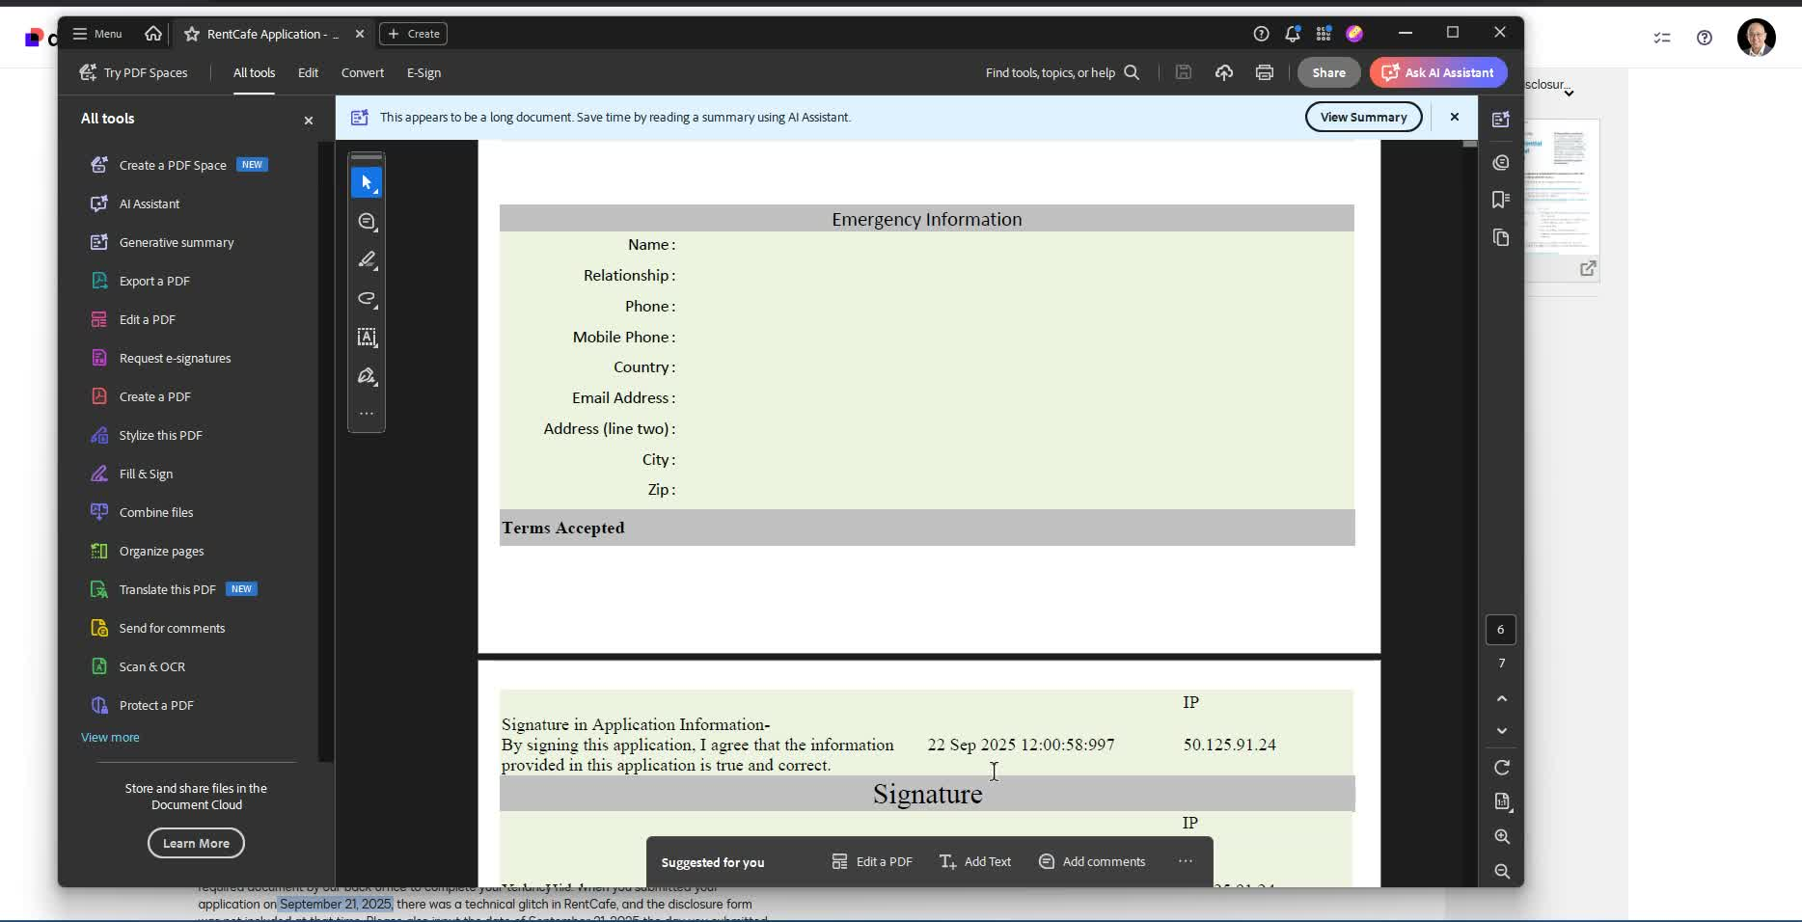
- Verify the date of application processing (e.g., September 21st).
- Ensure that the date aligns with compliance requirements.

3. Prepare the Disclosure Form 2:15
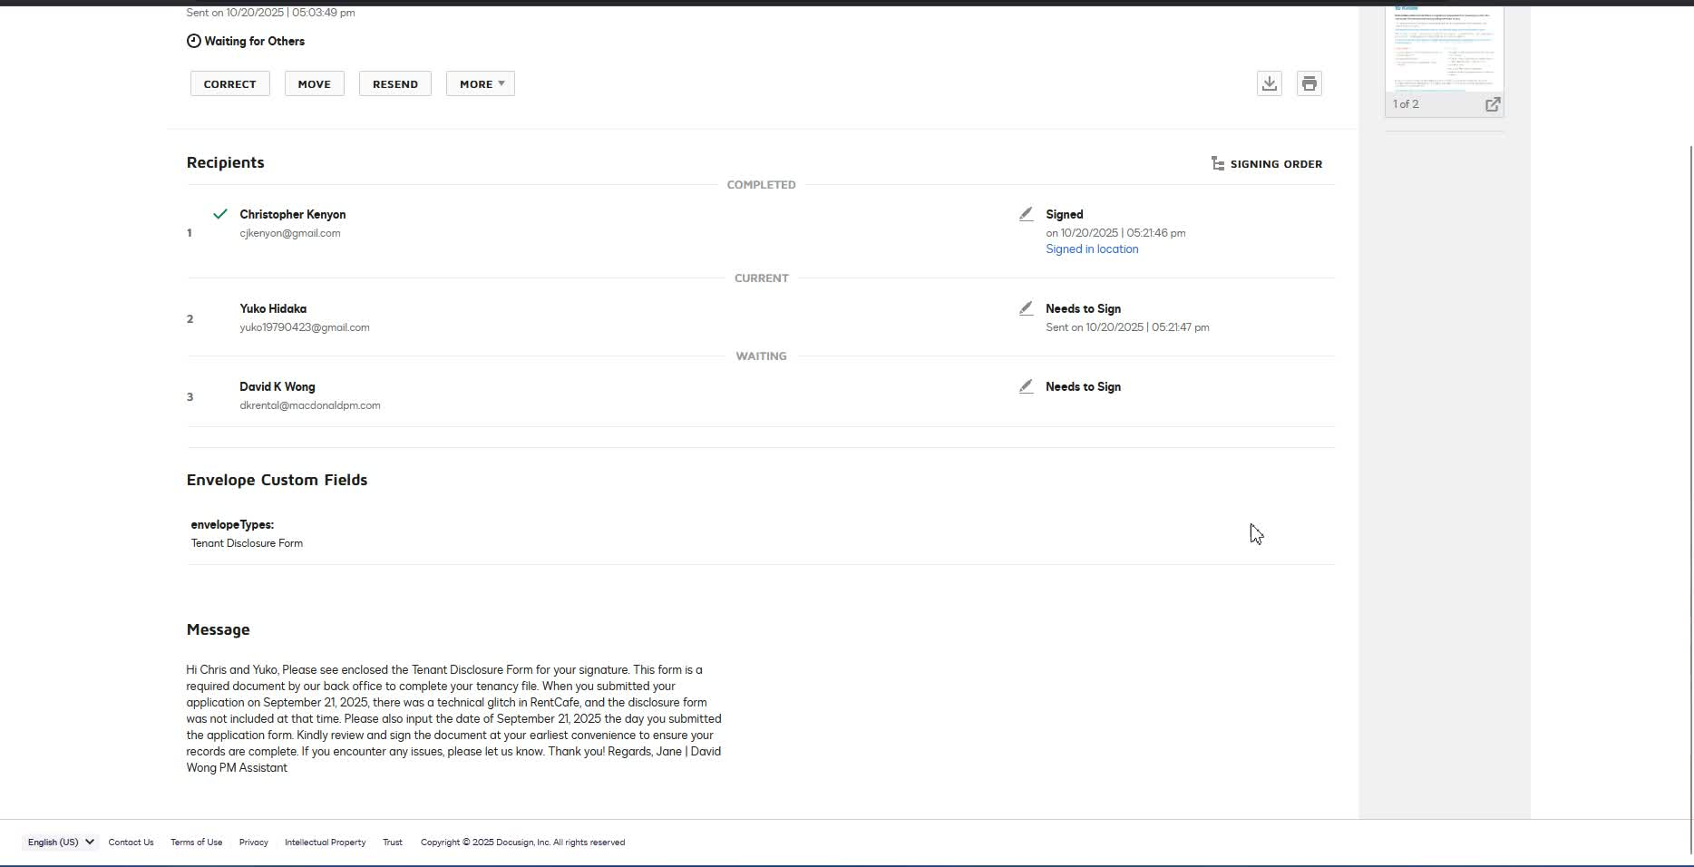
- Create the tenant disclosure form in two formats: one for a single applicant and one for two applicants.
- Ensure the document is clean and straightforward, avoiding clutter.

4. Set Up DocuSign for Signatures 5:40
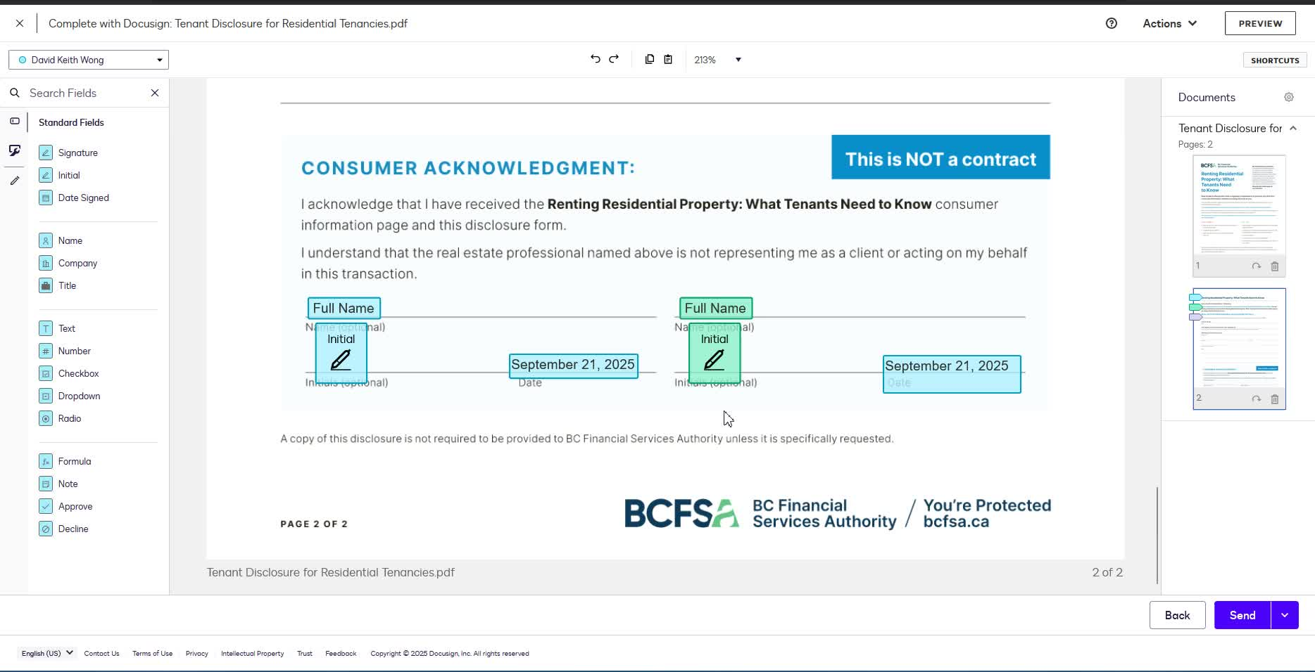
- Use DocuSign to set up the document for signatures.
- Ensure that the signature lines are aligned and organized.

5. Control Document Text and Dates 6:07
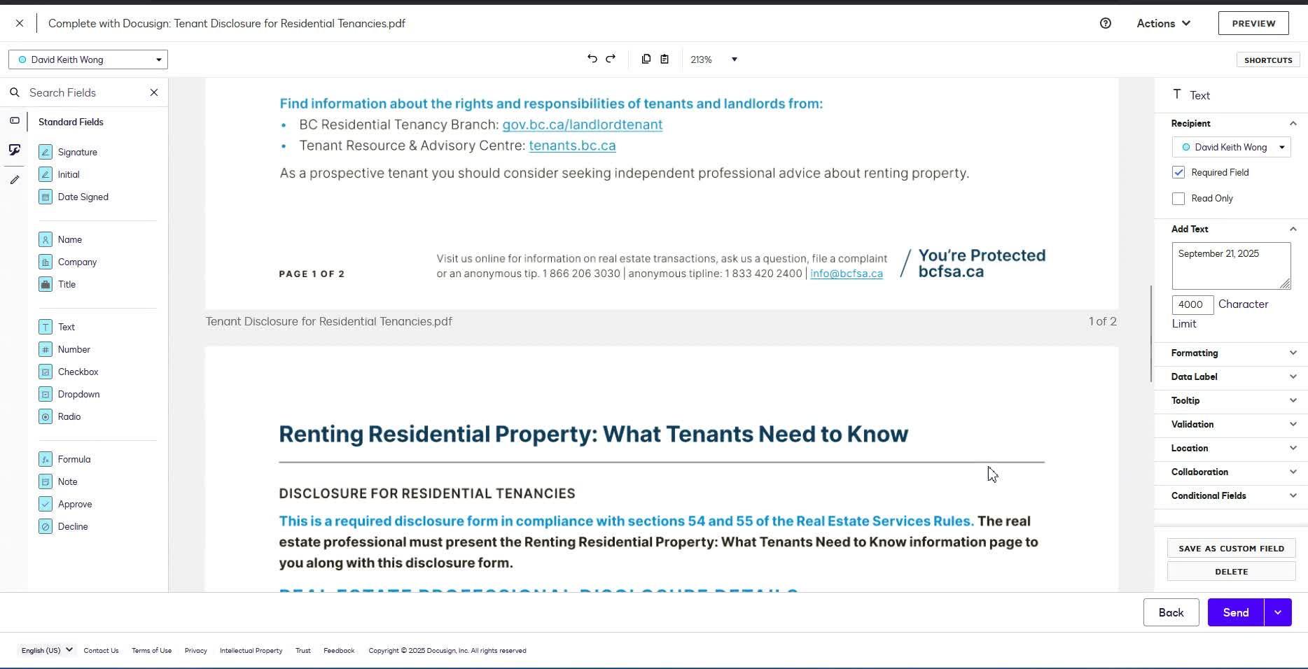
- Ensure that the text fields are controlled by the administrator (you).
- Set the date field to auto-populate when the tenant starts filling out the form.

6. Avoid Asking Tenants to Change Dates 9:40
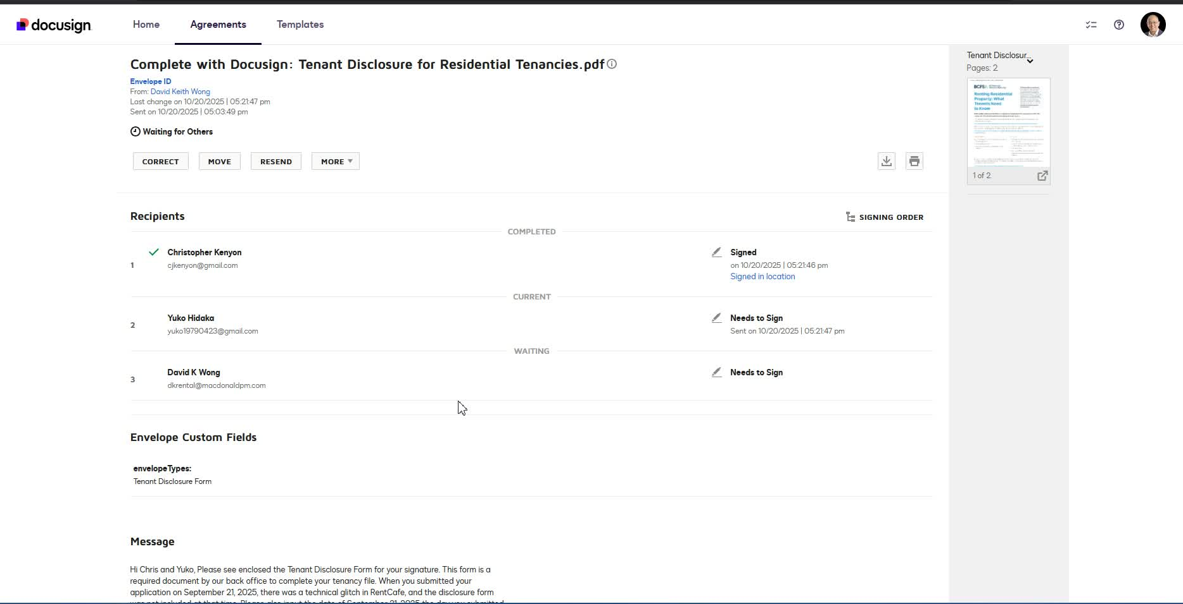
- Do not instruct tenants to change the date on the document.
- Ensure that the date is consistent with the application date to avoid confusion.

7. Finalize and Send the Document 13:11
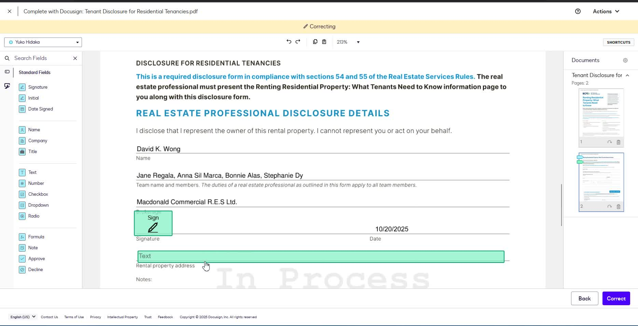
- Once all necessary fields are filled, finalize the document.
- Send the document to the tenant for signing.

8. Ensure Compliance with Date Alignment 14:56
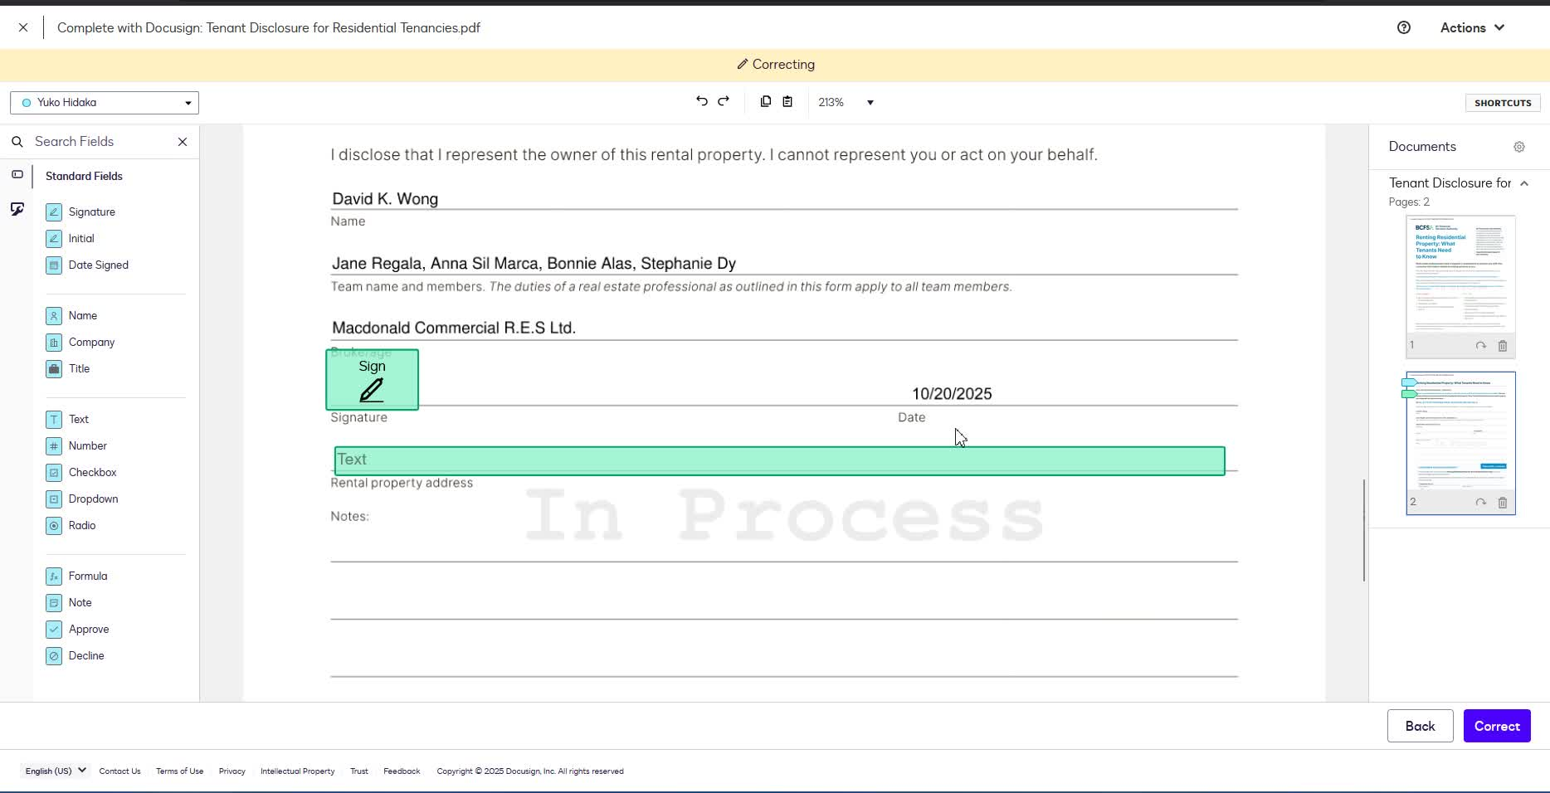
- Double-check that the dates on the tenant disclosure form align with the application form.
- Make any necessary adjustments before finalizing.
Cautionary Notes
- Always ensure compliance with local regulations regarding tenant disclosures.
- Avoid unnecessary complications by keeping instructions clear and concise for team members.
Tips for Efficiency
- Familiarize yourself with DocuSign features to streamline the process.
- Maintain a checklist of required fields to ensure nothing is overlooked before sending the document.
Link to Loom
https://loom.com/share/f08bd92d63694f32af714a02c31cfb40
Tenant Disclosure Form Process via DocuSign

1. Identify the Issue with the Tenant Application 0:00

- Tenant disclosure form needs to be sent via DocuSign due to a system error.
- The Rent Café application form did not include the mandatory disclaimer.
- Compliance requires the disclosure to be sent to avoid issues.

2. Confirm Application Processing Date 1:20

- Confirm the date of application processing (September 21st).
- Ensure that the team is aware of the correct date for compliance.

3. Send Disclosure Form to Tenants 1:54
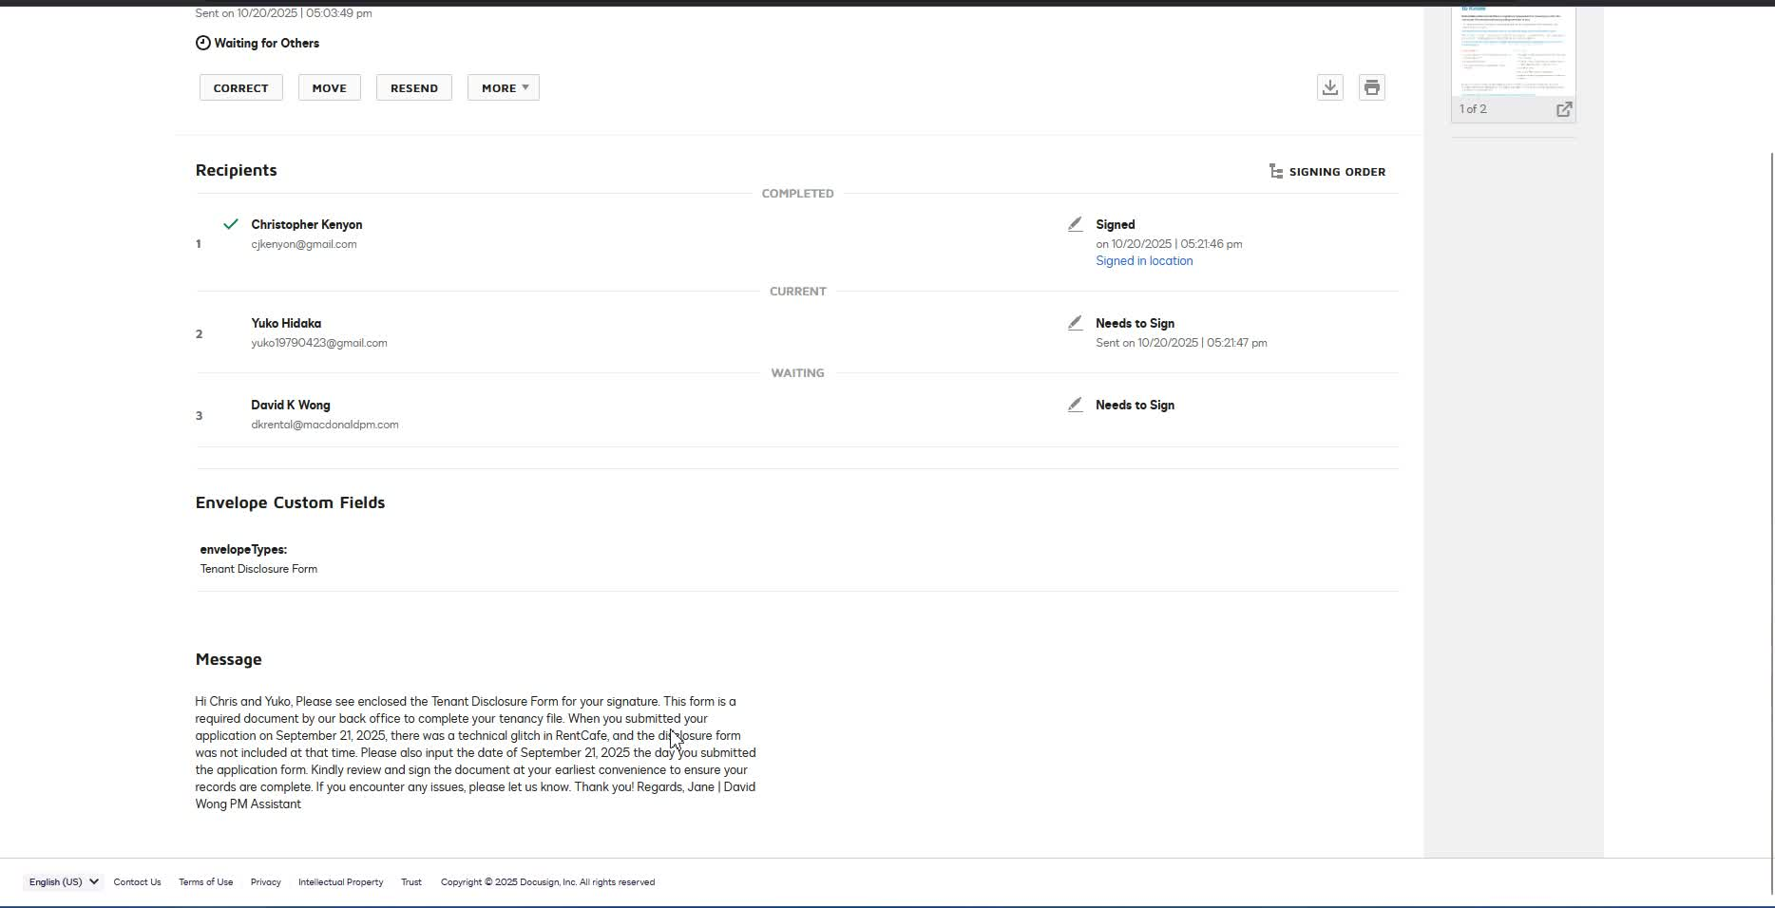
- Send the tenant disclosure form to both applicants (Christopher and Yuko).
- Provide clear instructions on what they need to do (signing the document).

4. Clarify Instructions for Team Members 2:15

- Emphasize that the team does not need to worry about the date discrepancies.
- Focus on the task at hand: signing and initialing the document.

5. Create a Clean Document for Signing 5:33
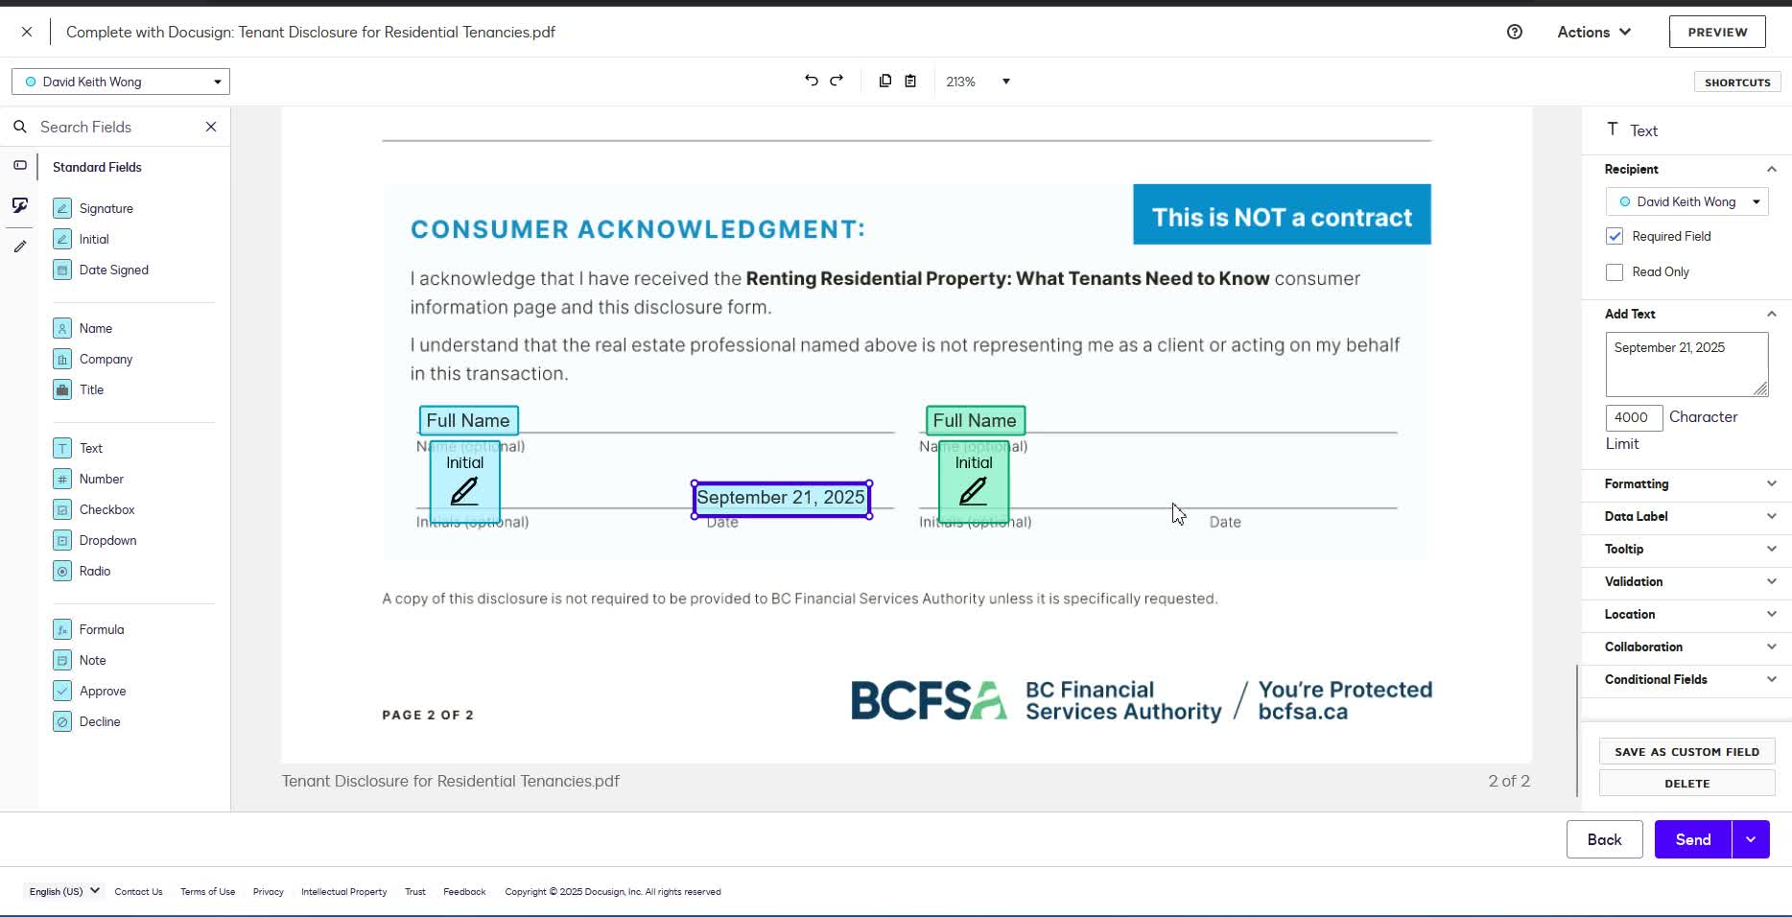
- Ensure the document is formatted cleanly for signatures.
- Avoid cluttered layouts; keep it straightforward.

6. Control Document Details 6:07

- As the administrator, control all text and details in the document.
- Ensure that the date is automatically populated when the tenant fills out the form.

7. Manage Signatory Order 9:40

- Decide the order of signatories (who signs first).
- Ensure that the process is efficient and clear for all parties involved.

8. Address Compliance Concerns 11:00
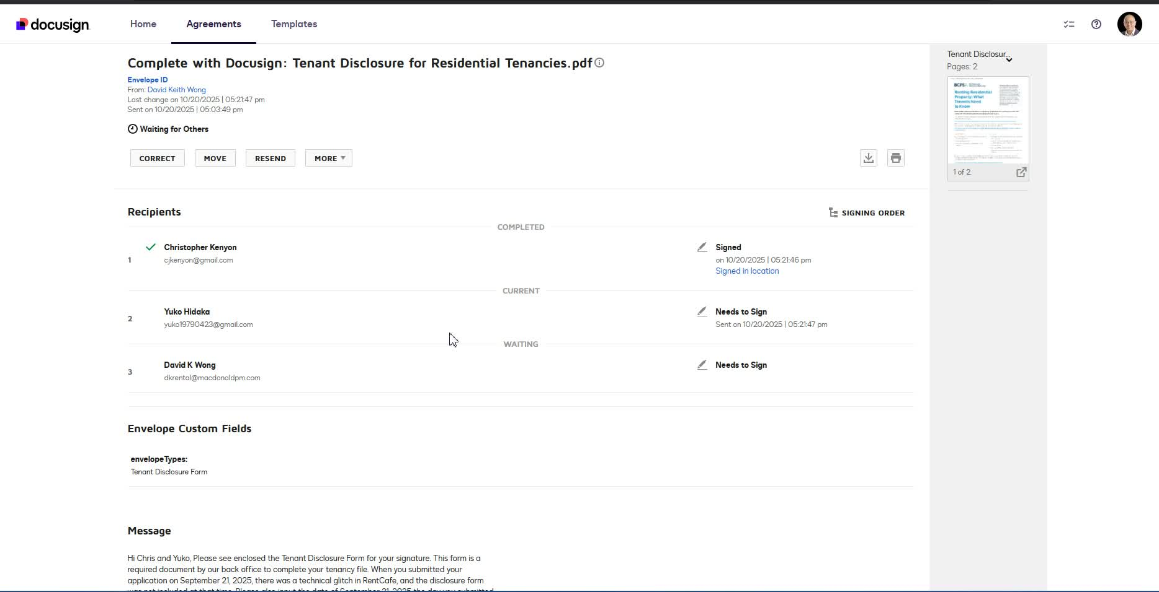
- Ensure that the dates on the disclosure form align with the tenant application for compliance reasons.
- Highlight the importance of having the correct dates to avoid regulatory issues.

9. Finalize Document and Send for Signing 13:35
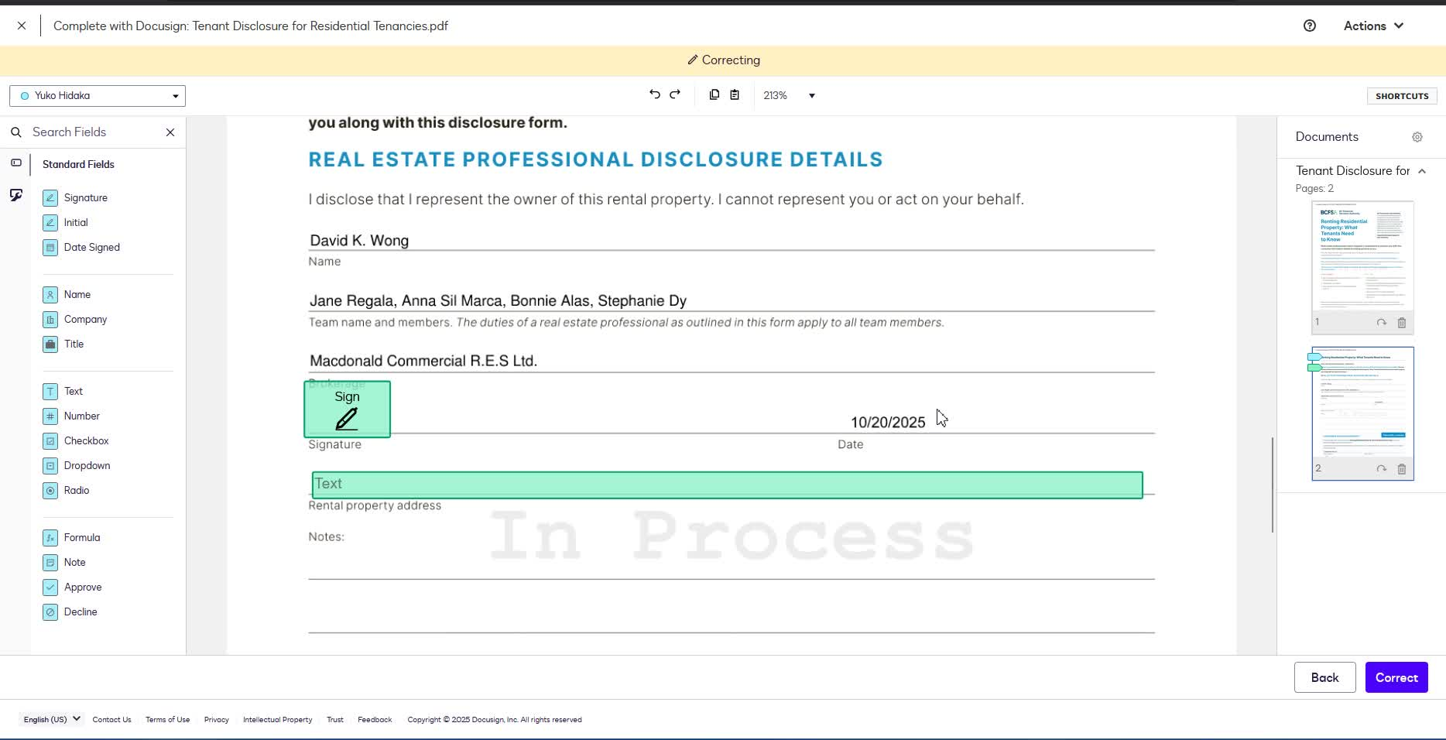
- Fill out necessary details (like rental property address) before sending the document.
- Confirm that all signatories have completed their parts.

10. Review and Follow Up 15:10
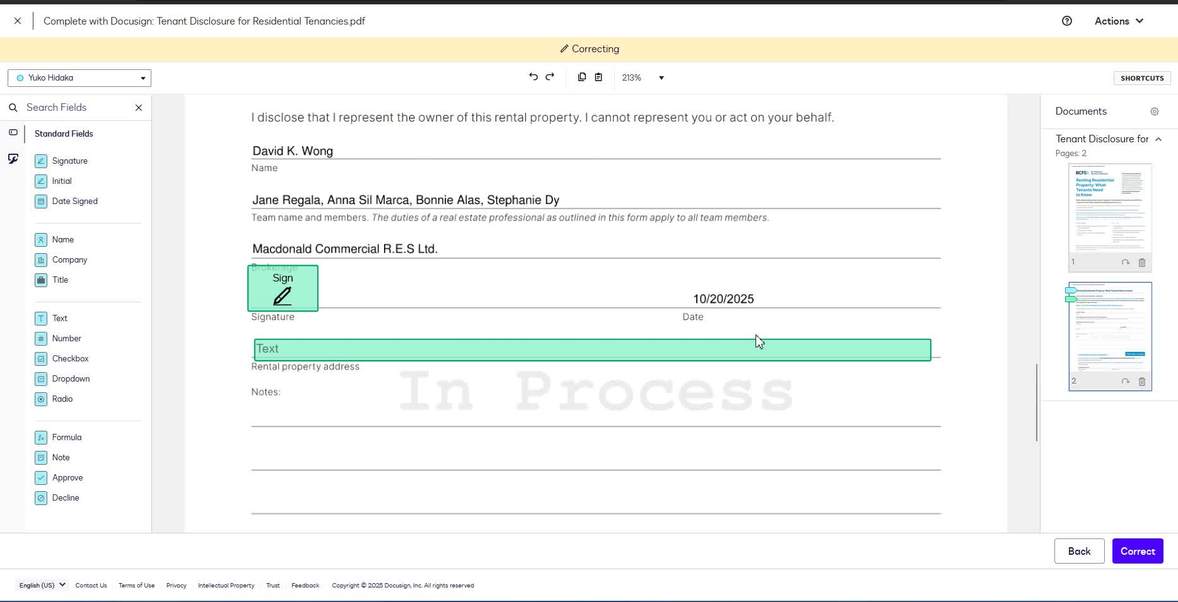
- Check that all documents are filled out correctly and in sync.
- Follow up with any tenants who have not completed their forms.
Link to Loom
https://loom.com/share/f08bd92d63694f32af714a02c31cfb40
Steps to Reproduce the Bug in Tenant Disclosure Form

1. Access the Rent Café Application 0:00

- Log in to the Rent Café application.
- Locate the tenant application that requires a disclosure form.

2. Identify Missing Disclaimer 0:39
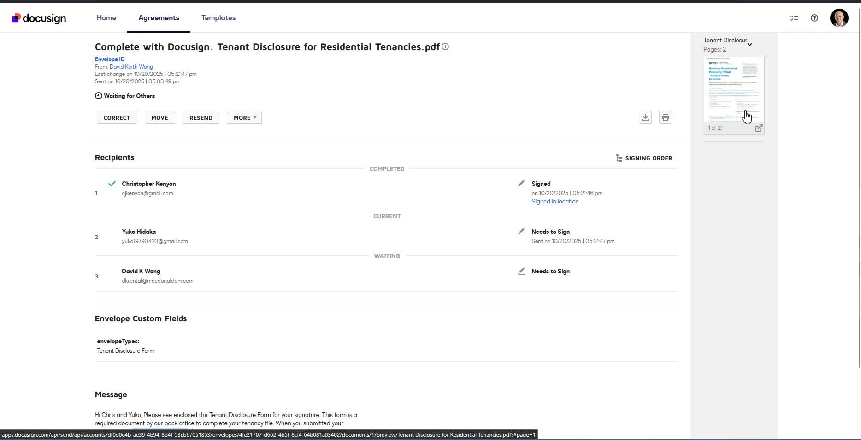
- Check the application for the mandatory disclaimer regarding consent to the credit check.
- Confirm that the disclaimer is missing.

3. Prepare the Tenant Disclosure Form 1:20

- Create a tenant disclosure form using DocuSign.
- Ensure the form is set up for two applicants if applicable.

4. Send the Form for Signing 2:23
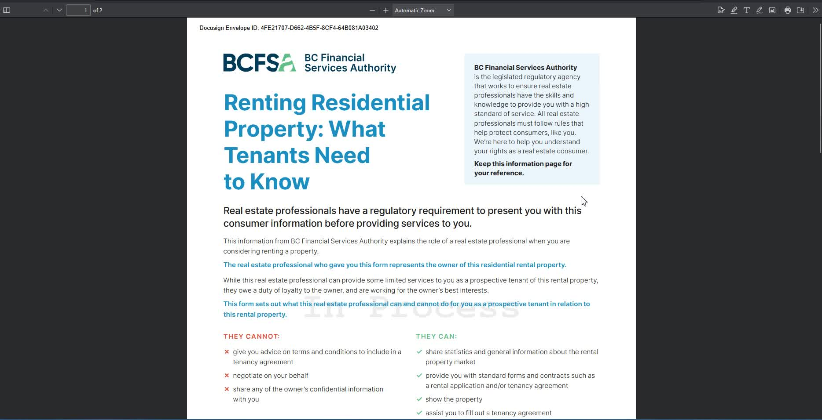
- Send the disclosure form to the applicants for signing.
- Ensure that the initial listing is included for both applicants.

5. Verify Date Stamping 7:00
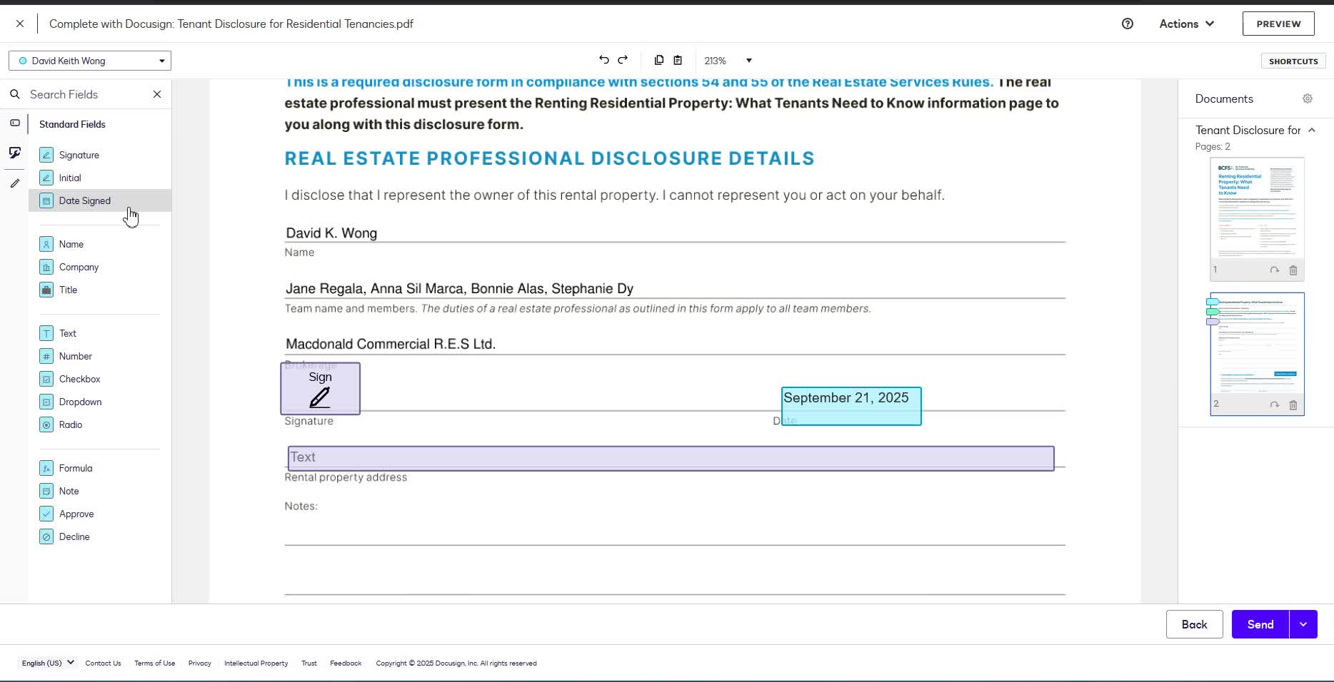
- Check that the date is automatically populated when the applicants start filling out the form.
- Ensure that the date aligns with the tenant application date.

6. Confirm Compliance with Dates 11:00

- Ensure that the date on the disclosure form matches the application date for compliance reasons.
- If discrepancies arise, adjust the date manually to avoid confusion.

7. Finalize the Document 13:35

- Once all signatures are obtained, finalize the document.
- Ensure that all information is consistent and compliant before submission.
Link to Loom
https://loom.com/share/f08bd92d63694f32af714a02c31cfb40

